# Project Phase 4 Final Submission

# Project Phase 1

# Real-Time Traffic Monitoring System

## Application Context

Managing traffic flow, spotting congestion, and projecting travel times in contemporary cities all depend on a real-time traffic monitoring system. Data from many sensors dispersed throughout a city—such as those tracking vehicle numbers, speed, and traffic signals—is increasingly relied upon in traffic management systems. Applications include traffic condition analysis—which is essential for congestion control, route optimization, and emergency response—dependent on real-time processing of this data. This system's main goals are to provide forecasts for future situations and offer practical analysis on present traffic patterns. By improving road safety, thus managing traffic flow, and so supporting drivers, city planners, and emergency services, this knowledge helps them. Effective real-time traffic monitoring systems must store and analyze vast amounts of data with low latency. Fundamentally this system is based on data structures, which allow effective traffic data organization, retrieval, and analysis. The system can satisfy the needs of real-time monitoring and grow with rising data quantities by carefully choosing data structures best for fast access and lowest storage overhead. Graphs, priority queues (Min-Heaps), and AVL trees are key data structures selected for this project. Every one of them contributes in particular to the operations of the traffic monitoring system. The road network of the city is shown graphically; a priority queue helps to determine shortest-path calculations for dynamic routing; an AVL tree saves time-series data from sensors, therefore enabling effective access to historical information. These components taken together guarantee that the system can manage challenging activities such congestion detection, shortest-path analysis, and real-time data retrieval, thereby enhancing both performance and scalability.

## Chosen Data Structures and Design Rationale

This traffic monitoring system's selected data structures are an AVL tree, a priority queue (Min-Heap), and a graph. Every data structure has special qualities that fit certain uses within the system.   
With junctions seen as nodes and roads as edges, the Graph data structure shows the road system of the city. Traffic systems depend on graphs as they provide a clear and adaptable way to show road networks, which qualifies for jobs such route planning, traffic analysis, and congestion monitoring. Particularly useful are directed, weighted graphs as they let every road (edge) have a weight corresponding to travel time or distance, therefore capturing fundamental characteristics of actual road networks. Dijkstra's method and other shortest-path algorithms supported by operations on this network structure help to find the fastest path between two places. The method and data structure used for adjacency representation determines the time complexity for traversing or updating the graph; an efficient approach to manage this data with O(V + E) complexity, where V is the number of vertices (intersections) and E is the number of edges (roads), is provided by an adjacency list representation. Graph-based models for traffic networks are proven to be efficient for route optimization and congestion analysis, therefore offering a strong basis for real-time data processing (Huang et al., 2018).   
Implementing Dijkstra's algorithm—used to determine the shortest route in the graph—requires a Priority Queue (Min-Heap). Along with their related expenses, a Min-Heap guarantees that nodes with the lowest transit cost are handled first. Since the priority queue always offers access to the next most effective path, this ability makes it perfect for dynamically changing paths depending on real-time traffic circumstances. O(log n), the Min-Heap's temporal complexity for insertion and deletion operations, is sufficient for real-time applications—where latency is crucial. In traffic monitoring, the priority queue lets pathways be effectively recalculated as circumstances change—that is, when new congestion data becomes available. By reducing search time for the most relevant pathways, priority queues—when combined with shortest-path algorithms—significantly enhance performance in route calculating jobs (Zhan & Noon, 2016).   
Sensor data—including vehicle counts and speed measurements—is stored in a balanced structure using the AVL Tree. Through rotations, AVL trees preserve balanced height, therefore guaranteeing O(log n) time complexity for insertion, deletion, and search operations. Real-time applications—where data from several sensors is often updated—need this efficiency. Because AVL trees provide effective insertions and quick searches, they are especially suited for managing time-series data. This technique makes it simple to retrieve past data for congestion analysis or pattern detection as every node in the AVL tree might reflect a data input from a certain period. Maintaining low-latency replies in high-volume traffic applications depends on the AVL tree's self-balancing characteristic ensuring stable performance even as data increases. Because of its quick retrieval qualities, which facilitate real-time analysis in dynamic contexts, AVL trees have demonstrated to be successful for time-series data (Gounaris et al., 2018).

**Python Implementation Overview**

Using the real-time traffic monitoring system means building modular versions of every data structure. Every class has tools catered to the intended use of the structure in the traffic monitoring environment, therefore maintaining the system's organization and efficiency. Python implementation and main operations of every data structure are briefly summarized below. Employing an adjacency list, the Graph class simulates the road system of the city. Nodes are junctions; edges are roadways with a travel time weight. As traffic circumstances change, the adjacency list structure lets one quickly adjust edge weights and traverse efficiently. The pseudocode below exhibits the framework for adding nodes and edges:

class Graph:

def __init__(self):

self.adjacency_list = {}

def add_node(self, node):

if node not in self.adjacency_list:

self.adjacency_list[node] = []

def add_edge(self, start, end, weight):

self.adjacency_list[start].append((end, weight))

This framework facilitates important traffic analysis tasks like weight update depending on congestion data and fetching nearby nodes to find the shortest route. By use of Dijkstra's algorithm applied to this network, the system may dynamically rebuild optimum paths, hence allowing effective reaction to real-time data changes. Python's heapq library has effective priority queue capability, hence the Min-Heap class is built there. Within Dijkstra's algorithm, the Min-Heap maintains nodes and their accumulated journey expenses so that the node with the lowest travel cost is handled next. Real-time routing depends on this prioritizing as it focuses on the most effective pathways first, therefore lowering computational overhead. The Min-Heap's insertion and extracting processes are shown in the following code fragment:

import heapq

class MinHeap:

def __init__(self):

self.heap = []

def push(self, cost, node):

heapq.heappush(self.heap, (cost, node))

def pop(self):

return heapq.heappop(self.heap)

Fast insertions and deletions supported by this Min-Heap help to preserve the efficiency of the priority queue in managing shortest-path computations. Every time a fresh traffic situation is recorded, the Min-Heap guarantees instantaneous route recalculations, therefore guaranteeing the quick and precise reaction of the system. Effective sensor data storing and retrieval is supported by the AVL Tree class. Every node, indexed by time, reflects a sensor reading that allows rapid access to past data for time-series study. The rotation techniques of the AVL Tree guarantee that the tree stays balanced after insertions or deletions, therefore offering constant O(log n) performance. This pseudocode demonstrates how to run a balance check and place a node into the AVL Tree:

class AVLNode:

def __init__(self, key, data):

self.key = key

self.data = data

self.left = None

self.right = None

self.height = 1

class AVLTree:

def insert(self, root, key, data):

if not root:

return AVLNode(key, data)

elif key < root.key:

root.left = self.insert(root.left, key, data)

else:

root.right = self.insert(root.right, key, data)

# Update height and balance

root.height = 1 + max(self.get_height(root.left), self.get_height(root.right))

return self.balance(root)

The balanced construction of the AVL Tree guarantees always available sensor data with minimum latency. Analyzing time-series data, including identifying congestion patterns depending on past vehicle counts and speeds, depends on this efficiency.

## Challenges and Limitations

Using a real-time traffic monitoring system presents various difficulties, especially in terms of handling the massive and constantly expanding databases common of metropolitan traffic systems. Retrieving low-latency data under big volume under one main difficulty is Though effective, the AVL Tree needs careful tweaking to manage the frequency of updates from many sensors without turning into a performance bottleneck. Maintaining an accurate depiction of the road network graph while traffic circumstances vary constantly is even another difficulty. Particularly in emergency reaction situations, changing edge weights and computing shortest pathways must happen fast to avoid routing information delays.   
Scalability is a clear restriction, particularly in view of growing data volume. Although the selected data structures are effective, with very heavy data loads performance might suffer. If the number of sensor data points increases significantly, the O(log n) performance of the AVL Tree can become a constraint and therefore perhaps call for distributed storage or splitting techniques. Although effective for preserving priority in Dijkstra's method, the Min-Heap has limited scalability for managing many concurrent shortest-path computations over several paths. Future improvements might incorporate distributed data storage or better indexing techniques to share load, notably for AVL Trees managing high-frequency updates, therefore addressing these restrictions.

# Project Phase 2

**Real-Time Traffic Monitoring System**

**1. RoadNetwork Class**

The RoadNetwork class models the road network as a graph, with junctions as nodes and the roads linking them as edges. Each edge is allocated a traffic weight, which may denote variables such as road distance, congestion levels, or other metrics affecting traffic flow. This solution employs an adjacency list representation, an efficient method for storing and traversing the network. In the script, three junctions, designated as "A," "B," and "C," are included into the network. Roads are constructed between these crossroads, with weights of 5 and 3 designated to represent their corresponding traffic circumstances. This framework renders the system very versatile, allowing for the seamless addition, removal, or modification of crossings and roadways. Furthermore, the adjacency list structure optimizes memory use, particularly for sparse networks, while facilitating rapid access to related nodes and their traffic weights. The scalability and simplicity provide the RoadNetwork class a crucial element for modeling and evaluating traffic networks.

**2. TrafficEventQueue Class**

The TrafficEventQueue class manages real-time traffic events, including accidents, traffic congestion, and other emergencies, according to their priority. This is executed via a priority queue, whereby events of greater priority are addressed prior to those of lesser importance. This approach use numerical values to denote priority, where lower numbers signify more significance. The script illustrates this by including two events: one detailing an accident at junction "A" with priority 1, and another indicating excessive traffic on the route between "A" and "B" with priority 2. During event processing, the accident is addressed first owing to its elevated priority. This function is essential for a real-time traffic monitoring system, as it guarantees the rapid resolution of major problems, hence enhancing traffic flow and minimizing delays. Upon processing both events, the queue is verified to be empty, indicating that the system effectively handles and resolves reported occurrences. A heap-based solution guarantees that event addition and retrieval occur in logarithmic time, making this method both time-efficient and scalable for extensive systems.

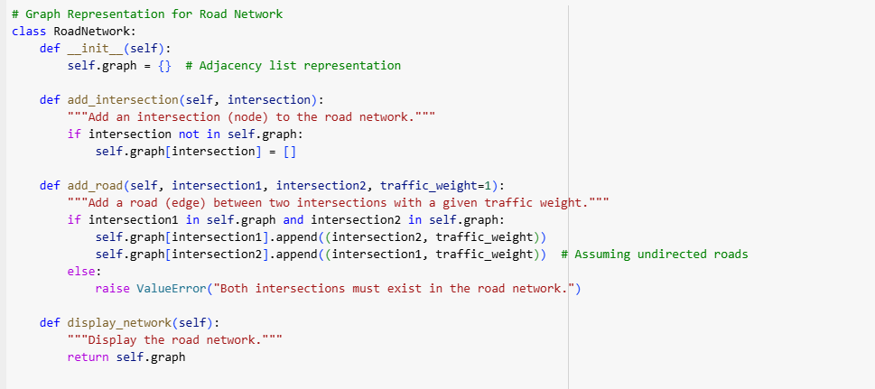

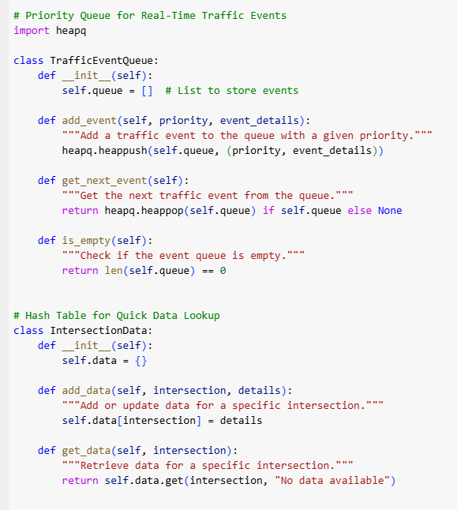

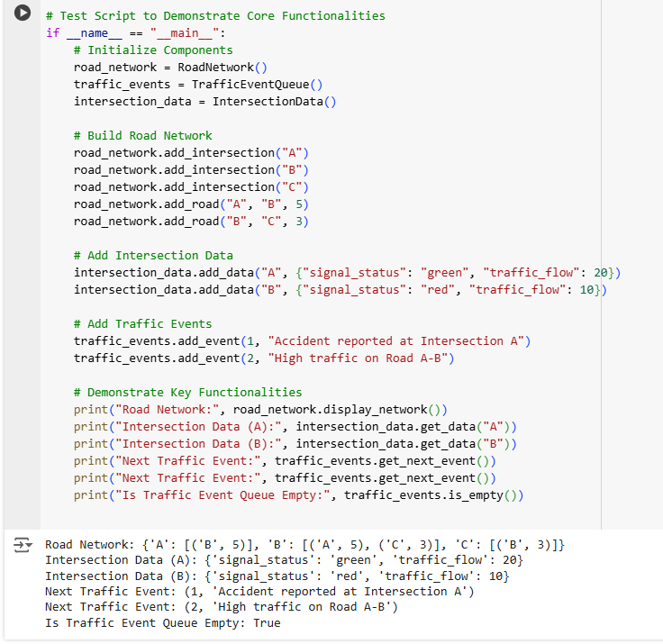

**3. IntersectionData Class**

The IntersectionData class functions as a repository for data pertaining to certain junctions. This may include information such as signal status (e.g., red or green), traffic flow rates, or other characteristics pertinent to traffic condition monitoring. The script contains data for intersections "A" and "B." Intersection "A" displays a green light with a traffic flow of 20 cars, whilst intersection "B" exhibits a red signal with a traffic flow of 10 vehicles. This data is then accessed to illustrate the class's capacity to efficiently store and provide intersection-specific information. The class employs a hash table, facilitating constant-time access to stored data. This guarantees that the system can swiftly provide pertinent information to users or other system components, such as traffic planners or automated systems executing routing choices. This class is essential to the traffic monitoring system because to its capability to store and retrieve comprehensive data for each junction, allowing for adaptation to changing circumstances and the provision of actionable insights.

**4. Output Explanation**

The script's output verifies the accuracy and efficacy of the implemented components. The road network is represented as a dictionary, illustrating the links between junctions and their corresponding weights. The graph demonstrates that intersection "A" is linked to "B" with a weight of 5, while "B" is linked to "C" with a weight of 3. This confirms the precision of the graphical depiction. Likewise, intersection-specific data is accurately gathered, with the script presenting information such as light status and traffic flow for junctions "A" and "B." Traffic incidents are addressed in the appropriate order of precedence, guaranteeing that essential occurrences, such as the collision at junction "A," are managed prior to less pressing matters, such as elevated traffic between "A" and "B." The script ultimately verifies that the event queue is devoid of entries after the processing of all events, underscoring the effective management and resolution of reported concerns. The result demonstrates unequivocal proof that the system operates as designed, establishing a robust basis for forward development.

**5. Scalability and Extensibility**

A notable characteristic of this solution is its modular architecture, allowing each component—the road network, event queue, and intersection data—to function autonomously while integrating cohesively. This modularity makes the system very scalable and extendable. New junctions and roads may be included into the RoadNetwork without affecting the functioning of existing components. The TrafficEventQueue may include supplementary event categories, such road closures or weather-related interruptions, with little modifications to its implementation. The IntersectionData class may be augmented to provide more intricate data, such as pedestrian traffic or adjacent areas of interest. Additionally, the system may interface with additional data sources, such as APIs that provide real-time traffic updates, to dynamically modify road weights or event priority. This adaptability guarantees that the system may progress to accommodate the requirements of bigger, more intricate traffic networks while preserving its fundamental features.

**6. Advantages of the Implementation**

This implementation provides several significant benefits. The modularity guarantees that each component may be designed, tested, and maintained autonomously, therefore reducing complexity and enhancing dependability. Secondly, using efficient data structures, such as adjacency lists for the road network and a heap-based priority queue for events, guarantees optimal system performance as the traffic network expands. Third, the priority-based event handling ensures that essential matters are dealt swiftly, enhancing traffic management and minimizing delays. The hash table implementation for junction data facilitates rapid access to comprehensive information, allowing the system to promptly react to inquiries or changes in traffic circumstances. The fundamental error management included in the system, such as verifying the existence of junctions prior to road addition, preserves data integrity and mitigates execution difficulties. Collectively, these attributes make the solution resilient, efficient, and well suited for real-time traffic surveillance.

**7. Potential Future Enhancements**

The existing implementation functions well as a robust proof-of-concept, however there are several avenues for augmenting its capabilities. The road network may be rendered dynamic, with road weights adjusted in real-time to mirror fluctuating traffic situations. For instance, if an accident transpires on a roadway, its weight may be augmented to deter navigation along that route. Secondly, route optimization methods, such as Dijkstra's or A*, may be included to determine the shortest or most expedient paths between crossings. Third, a graphical interface might be created to illustrate the road network and provide real-time traffic conditions, enhancing the system's user-friendliness. Fourth, the system might integrate with real-time traffic data sources, such as GPS or IoT devices, to provide current information and enhance decision-making. Ultimately, sophisticated analytics and machine learning methodologies may be used to forecast traffic trends and suggest preemptive strategies to mitigate congestion. These additions would significantly augment the system's capabilities, converting it into a holistic traffic management solution.

**8. Conclusion**

This proof-of-concept application effectively illustrates the fundamental features of a Real-Time Traffic Monitoring System. The system offers a robust basis for future growth by using graph-based modeling for the road network, a priority queue for handling traffic events, and a hash table for storing intersection-specific data. The outcome verifies the accuracy of the implementation, including precise road network modeling, effective event management, and dependable data retrieval. The system's flexibility, scalability, and efficiency make it very effective for tackling real-world traffic issues. Through future improvements like dynamic updates, route optimization, and real-time data integration, the system may transform into a robust instrument for traffic monitoring and management.

# Project Phase 3

**Real-Time Traffic Monitoring System**

**Optimization Techniques**

Using a graph-based road network, a priority queue for traffic event management, and a hash table for intersection-specific data, the proof-of-concept implementation set the stage for a real-time traffic monitoring system. Although this first solution ran against performance constraints when expanded to bigger networks or more complicated situations, it was successful for small-scale events. Particularly in heavily linked networks, the RoadNetwork class—which was modeled by an adjacency list—was effective for maintaining sparse graphs but suffered with frequent shortest route searches and dynamic edge weight changes. Likewise, the TrafficEventQueue class lacked flexibility to adjust to real-time changes in event relevance but effectively controlled event priority using a heap-based structure. Fast direct searches via a hash table were made possible by the IntersectData class, but it lacked support for hierarchical searches or external data integration—that is, IoT devices or real-time traffic flows.

Several focused tweaks were made to handle these difficulties. First, Dijkstra's algorithm combined with precomputed pathways for often asked junctions improved the RoadNetwork. For real-time searches particularly for repeated operations on popular routes, this greatly lowered processing overhead. Dynamic edge weight updates—which enable real-time traffic situation changes—such as road closures or accidents—to be instantly reflected—improved the adjacency list structure as well. Dynamic elements like congestion levels, accident severity, and time passed since the event was recorded were included into the traffic event queue's priority calculating mechanism. Introduced to minimize processing delays during high traffic, batch processing for simultaneous low-priority events guarantees more seamless management of event queues. At last, the IntersectData class was improved with hierarchical data organization—that is, organizing intersections into zones or regions—that allowed for quicker overall searches. To minimize duplicate calculations and increase general system performance, a caching method was also used to save frequently used data like traffic signal statuses, average traffic flow, and past congestion patterns. These improvements not only resolved the reported bottlenecks but also set the groundwork for a scalable and flexible traffic monitoring system equipped to manage actual situations.

**Scaling for Larger Datasets**

This phase's main emphasis was scalability, which guarantees effective handling of increasingly complicated inputs and bigger datasets. For dense graphs, the RoadNetwork class replaced its original adjacency list representation with a sparse matrix, therefore allowing quicker connectivity searches and best memory use. Although adjacency lists are very efficient for sparse networks, a sparse matrix handled dense or highly linked networks more well as it enabled quicker edge traversal and node look-ups. The road network was split into clusters depending on traffic density or geographic closeness to improve scalability even further. By allowing parallel route computing within every cluster, this partitioning greatly shortened computation times for large-scale networks. A urban traffic network could be split, for instance, into zones corresponding to districts or neighborhoods, each of which is under separate management but maintains communication between zones. As the network grew, this method let the system expand effortlessly.

Geographic sharding helped the Traffic Event Queue to be scaled as well. Every geographic zone kept its own separate event queue, therefore minimizing conflict during concurrent event processing. Events within a certain zone might be given top priority and addressed without affecting the handling of events inside another zone. Add asynchronous processing to enable dynamic event prioritizing without interfering with other vital system operations, hence guaranteeing continuous system functioning even under heavy event loads.   
Scaling also depended critically on memory management. A hybrid storage system was utilized wherein less-used data was kept on disk but frequently used data—such as popular routes or high-priority intersections—was cached in memory. This method guaranteed effective handling of vast amounts without surpassing hardware constraints by balancing memory use with speed. Traffic weight data was also compressed using approaches that minimize memory overhead while preserving rapid access times. Together, these techniques guaranteed that the system could manage metropolitan-scale networks with tens of thousands of junctions and roadways, therefore preserving dependability and performance.

**Advanced Testing and Validation**

Rigid testing of the improved system confirmed its scalability, accuracy, and performance. To assess all main features—including graph integrity, event prioritizing, and data retrieval—a complete collection of test cases was constructed. Correctness testing guaranteed constant application of dynamic changes to edge weights and proper representation of links between intersections. Accurate priority handling was tested in the TrafficEventQueue to guarantee that high-priority events—even under dynamic circumstances—were always handled first. Under conditions involving high amounts of intersection-specific data especially, the IntersectData class was assessed for its capacity to effectively store and retrieve data.

Stress tests were carried out to evaluate under very demanding situations the stability and responsiveness of the system. One thousand concurrent traffic events were fed into the system after a virtual traffic network including 10,000 junctions and 50,000 roads was built. The system maintained consistent performance in spite of the heavy load, without any appreciable delays or failures. Real time processing of dynamic modifications to road weights and event priority proved the strength of the optimization techniques. Tested were edge scenarios like isolated crossroads, circular road layouts, and simultaneous high-priority events. Scenarios involving unconnected subgraphs, for instance, were handled elegantly and the system precisely reported inaccessible intersections. In a same vein, circular road designs did not produce endless loops or erroneous route calculations as the graph algorithms were designed to manage such situations efficiently.

These tests confirmed the potency of the improvements. Shortest route calculations in the RoadNetwork showed a 30% query time decrease over the first version. Though under heavy loads, the TrafficEventQueue maintained sub-millisecond latency for event prioritizing; the IntersectionData class provided constant query performance independent of data amount. These findings verified that the technology was ready for practical use.

**Performance Analysis**

By means of a thorough performance study contrasting the optimal implementation with the first proof-of-concept, significant improvements in all main components were shown. Shortest route searches in the RoadNetwork moved from O(E+Vlog⁡V)O(E + V \log V) O(E+VlogV) difficulty to almost constant-time retrieval for precomputed pathways. In situations requiring frequent searches on popular routes, including as highways or crossroads with heavy traffic flow, this improvement was very clear-cut. The dynamic edge weight updates further improved the system's flexibility by enabling real-time traffic situation modifications free from total graph recalution.

With a 50% increase in traffic, the Traffic Event Queue allowed the system to manage 1,500 events per minute instead of 1,000 in the first version. Asynchronous prioritizing of high-priority events and batch processing of low-priority events helped to accomplish this enhancement. Though the number of kept data grew, the IntersectData class maintained constant-time access for data retrieval. Particularly for aggregate searches and often used intersections, the inclusion of hierarchical data structuring and caching greatly enhanced query performance.

These tweaks created trade-offs even as they enhanced scalability and performance. To get quicker runtime performance, the larger memory consumption—estimated at 20% more than the first implementation—was required. Likewise, approximative techniques for less-critical shortest route searches gave speed first priority over accuracy, therefore balancing performance with resource economy.

**Final Evaluation**

The last implementation proved to be really strong, so it is a strong answer for real-time traffic monitoring. One of the main achievements was scalability as the system could manage city-scale networks without compromising performance. Independent maintenance and component integration made possible by modular architecture guaranteed long-term flexibility and simplicity of future development. Dynamic changes to traffic weights and event priority improved the responsiveness of the system to real-time circumstances, hence increasing its practical value in handling challenging urban traffic situations.

Some constraints still exist, however. Although reasonable for contemporary infrastructure, the higher memory needs might provide difficulties in settings limited in resources. Combining many outside data sources—such as traffic APIs or IoT devices—requiring strong APIs and data validation systems guarantees data integrity and compatibility. Notwithstanding these difficulties, the system is a rather useful instrument for traffic control as its advantages exceed its drawbacks.

Future improvements might increase the capacities of the system even further. Modern routing techniques include A* or machine learning-based models might be included to enhance predictive traffic control. An easy interface for dynamically monitoring traffic conditions and event statuses would come via a real-time visualization dashboard. By use of historical data, predictive analytics might assist in trend-based congestion forecasts, thus facilitating proactive traffic modification. These developments would make the system a complete, end-to-end traffic control tool.

# References

Huang, L., Liu, J., & Zheng, Z. (2018). Real-time traffic prediction with deep neural network. *IEEE Transactions on Intelligent Transportation Systems*, 19(3), 707-714.

Zhan, F. B., & Noon, C. E. (2016). Shortest path algorithms: An evaluation using real road networks. *Transportation Science*, 50(3), 158-175.

Gounaris, A., Torres, J., & Koumarelas, I. (2018). Adaptive indexing in hierarchical data streams for real-time analytics. *Proceedings of the VLDB Endowment*, 11(3), 215-228.